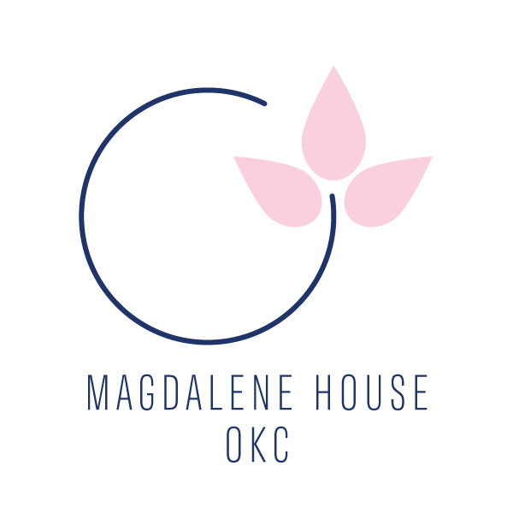

Dear,
I hope this letter finds you well. We are reaching out to you on behalf of Magdalene House OKC, a dedicated organization committed to the rehabilitation and empowerment of women who have experienced various forms of trauma and abuse in their lives. Our mission is to provide a supportive environment where these women can rebuild their lives, regain their independence, and reintegrate into society.
We are excited to announce our upcoming fundraising luncheon, scheduled for Thursday, April 11th at All Souls Episcopal Church. This event is a crucial part of our fundraising efforts, and we are actively seeking sponsors to join us in making a lasting impact on the lives of these women.
By becoming a sponsor, you will contribute directly to the success of our programs and initiatives. Your generous support will enable us to provide essential resources, counseling services, vocational training, and housing assistance to the women in our care. Your sponsorship will not only help transform individual lives but also contribute to the overall well-being of our community.
Sincerely,
Magdalene House OKC

Spring Luncheon Sponsorship Form

Event Details:
- Date: Thursday, April 11, 2024
- Time: 11:30 am arrival, program begins at 12:00 pm
- Venue: All Souls Episcopal Church, 6400 N. Pennsylvania Ave, OKC, OK 73116

Sponsorship Levels:

Event Host Sponsor - $10,000
- Recognition as Lunch Sponsor in all event materials
- Verbal acknowledgment during the event
- Table for 10 guests at the luncheon

Lunch Sponsor- $5,000
- Recognition as Lunch Sponsor in all event materials
- Verbal acknowledgment during the event
- Table for 10 guests at the luncheon

Curbside Flowers Floral Sponsor - $2,500
- Recognition in program materials
- Verbal acknowledgment during the event
- Table for 10 guests at the luncheon

Table Sponsor $1,000
- Recognition in program materials
- Table for 10 guests at the luncheon

Friend of Magdalene House OKC- $200
- Seating for you and 1 guest
- Receive the Curbside Flowers Floral Centerpiece as a thank you for your friendship

Sponsor Information:

Payment Method:
- Check (Please make checks payable to Magdalene House OKC)
- Credit Card - (www.magdaleneokc.org, donate, select: “luncheon”)

Logo Submission:
- Please submit your organization's logo in high resolution to: shannon@magdaleneokc.org

Contact Information:
- Organization Name: Magdalene House OKC
- Contact Person: Shannon Hartsock
- Email: shannon@magdaleneokc.org
- Phone: 405-488-4604

Additional Comments or Special Requests:

Thank you for your generous support! Your contribution helps Magdalene House OKC continue our work creating a home for women survivors; transforming trauma into healing, wholeness, and love.
A representative will contact you to confirm your sponsorship details.

